WELCOME

PROJECT TITLE

UNCOVERING THE GAMING INDUSTRY’S HIDDEN GEMS : A COMPREHENSIVE ANALYSIS OF VIDEO GAME SALES 

SUBMITTED BY

TEAM LEADER : ARTHISHA R S

TEAM MEMBERS : ASHLIN KIRUBA V S

ASHMITHA R

ASWINI J

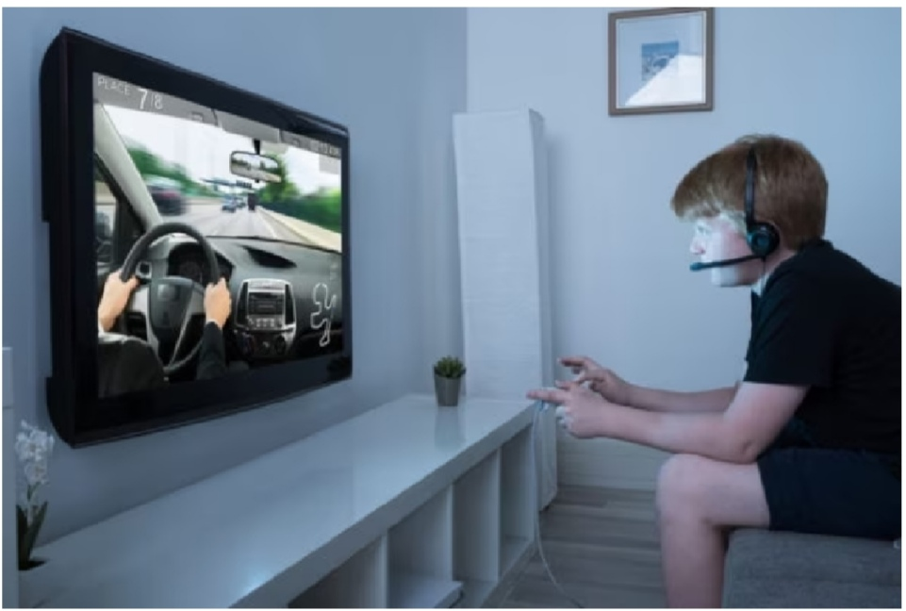

PROJECT REPORT

1. INTRODUCTION
   1. OVERVIEW
   2. PURPOSE

2.PROBLEM DEFINITION &DESIGN THINKING

2.1 EMPATHY MAP

2.2 IDEATION &BRAINSTORMING MAP

3.RESULT

4.ADVANTAGES AND DISADVANTAGES

5.APPLICATION

6.CONCLUSION

7.FUTURE SCOPE

1.INTRODUCTION

1.1 OVERVIEW

A Video is an electronic game that involves interaction with a user interface or input device to generate visual feedback from a display device, most commonly show in a video format on a television set, computer monitor, flat – panel display or touch screen on handheld devices. Video game sales analysis is the process of collecting and analyzing data about the sales of video games in order to understand market trends and consumer behavior.

1.2 PURPOSE

This project tells us the improvement of gaming industry’s video game sales in various countries. It helps to understand more about gaming industry.

2. PROBLEM DEFINITION & DESIGN THINKING

2.1 EMPATHY MAP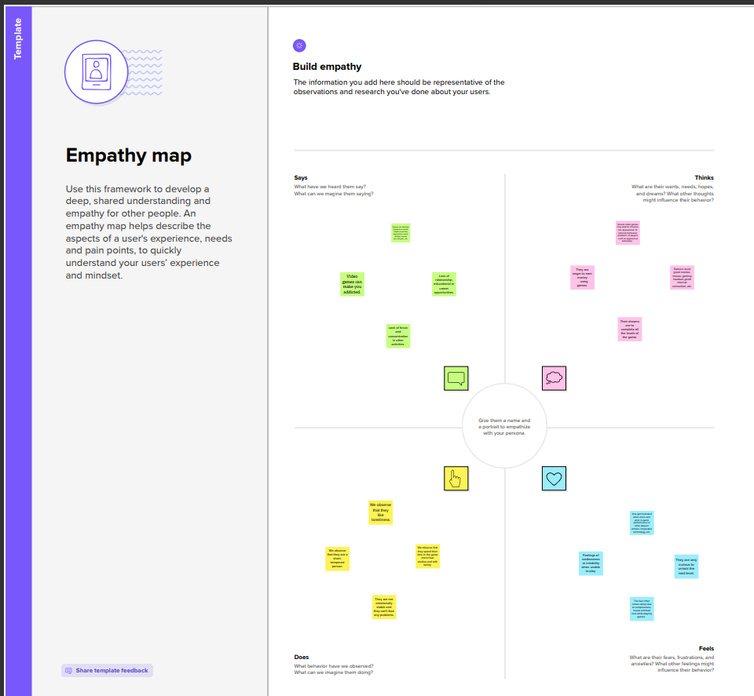

2.2 BRAINSTORMING AND IDEATION MAP

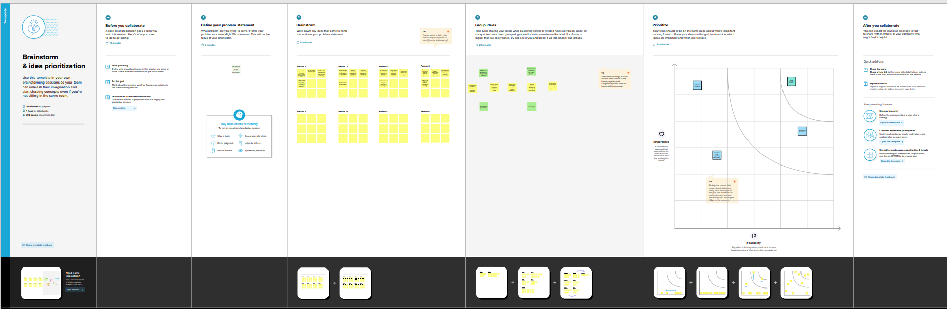

1. RESULT

DASHBOARD

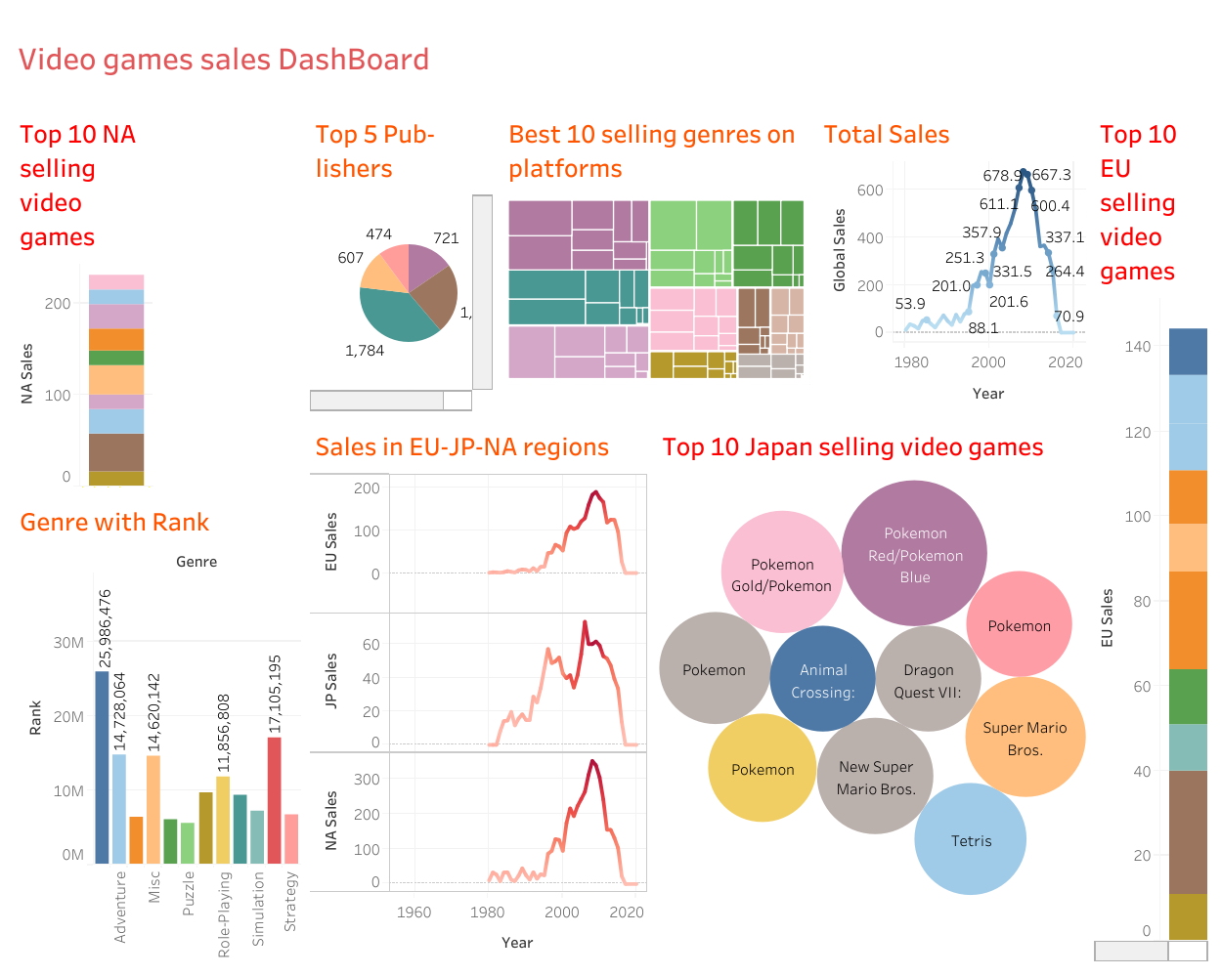

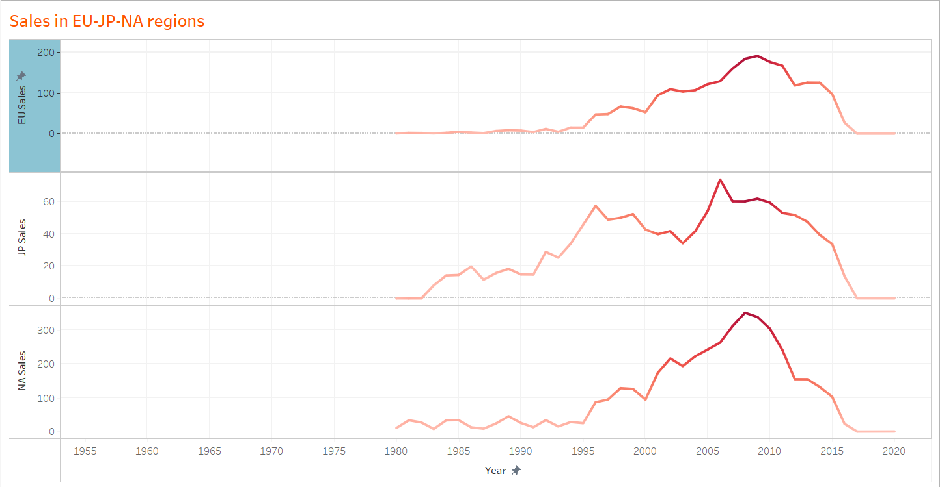

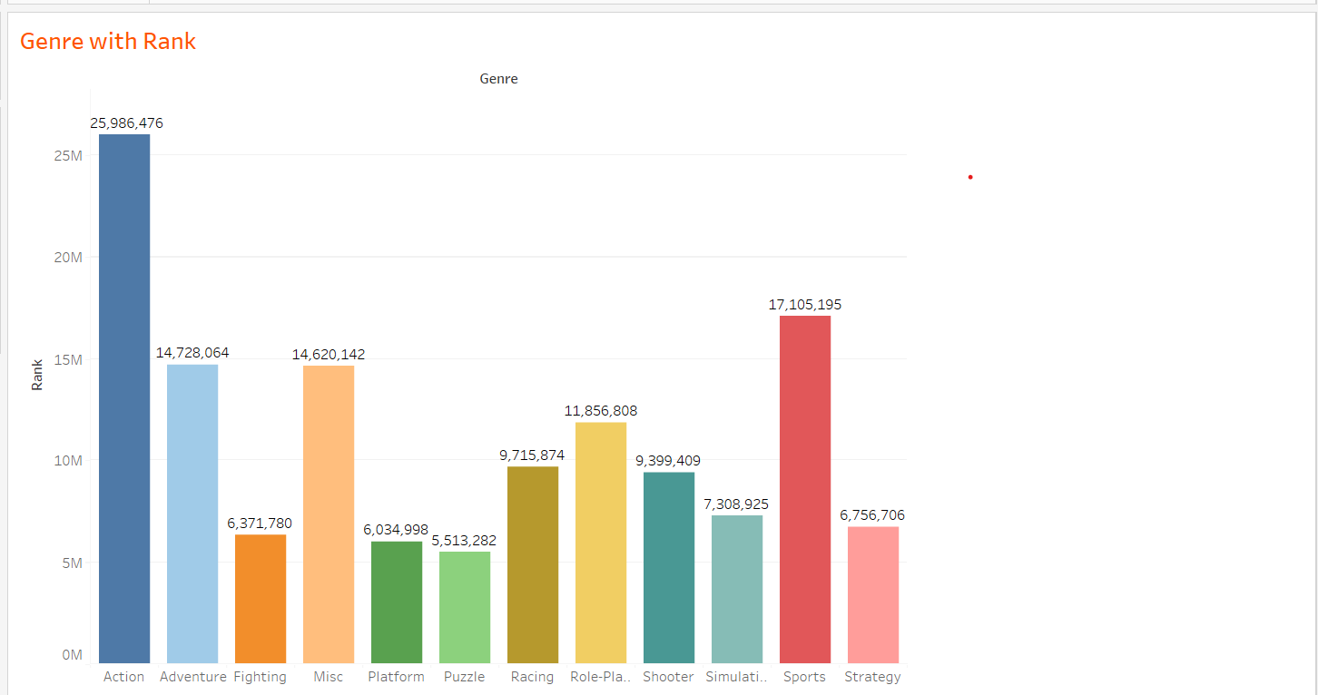

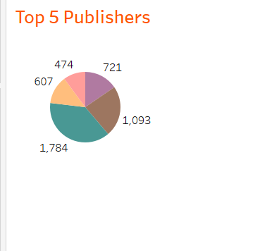

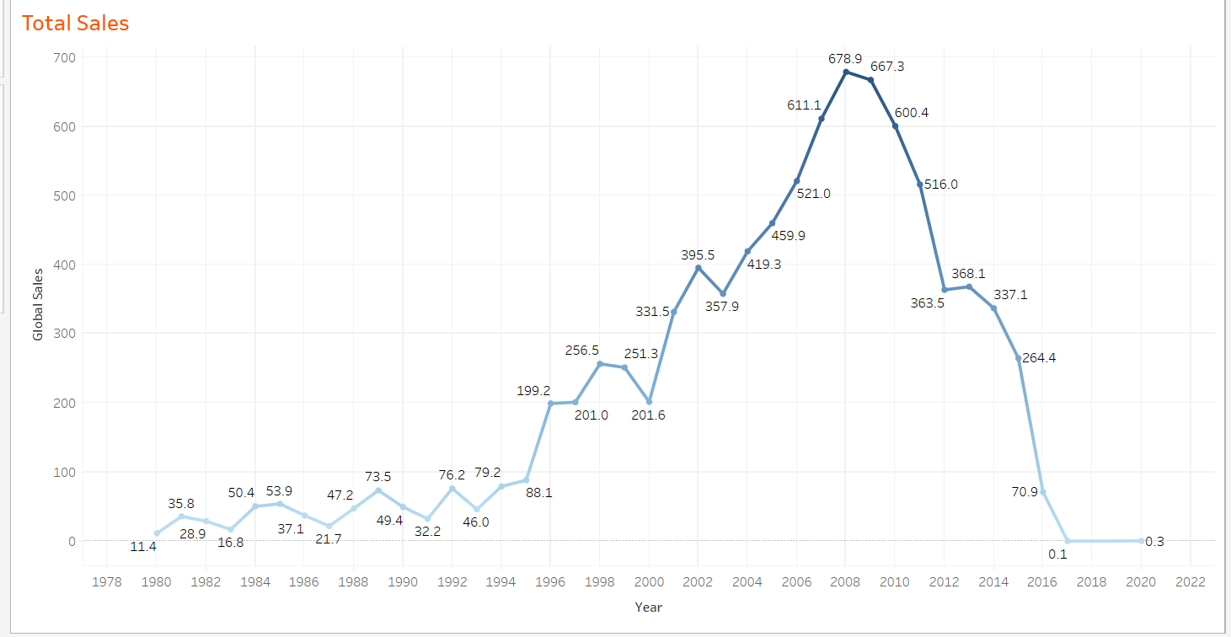

STORY

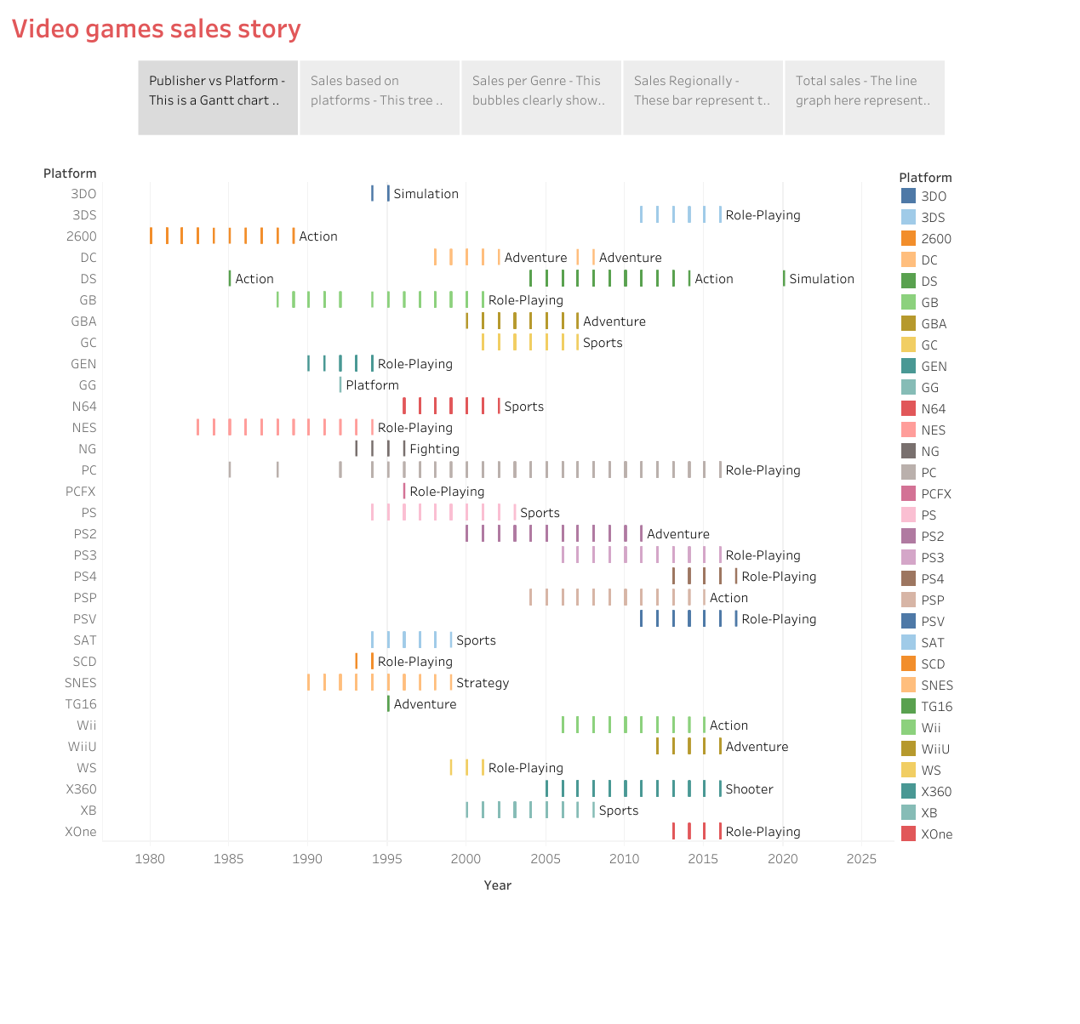

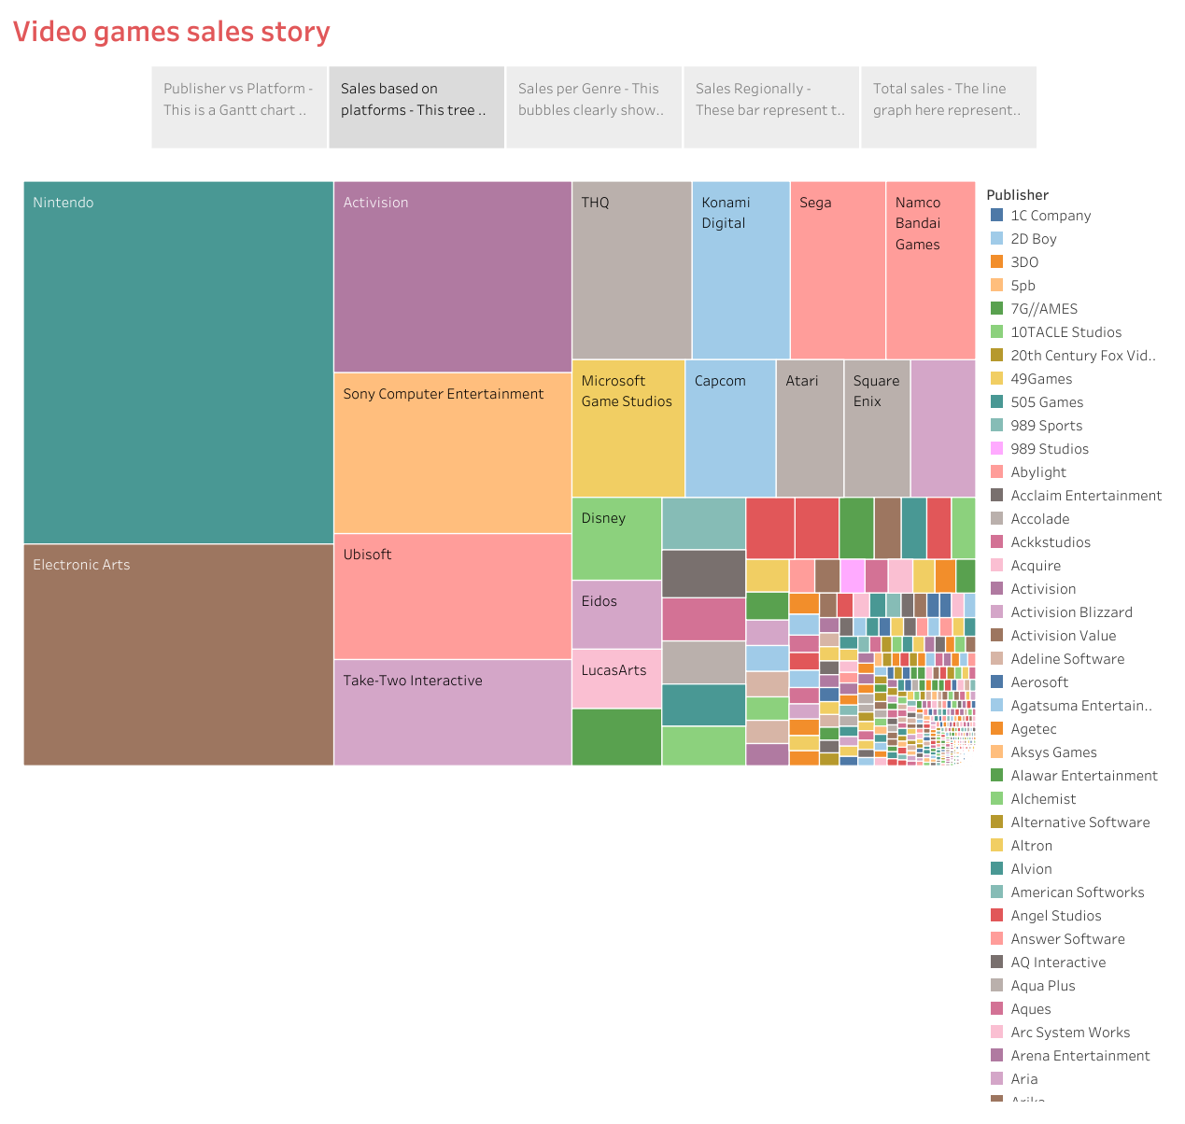

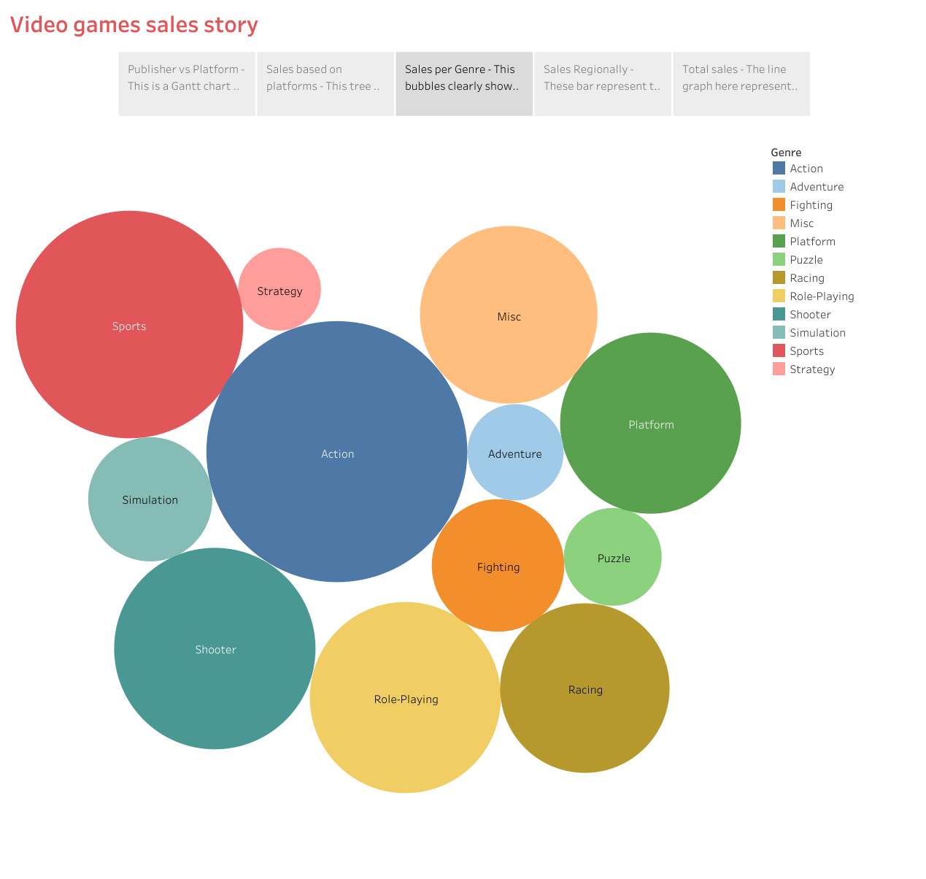

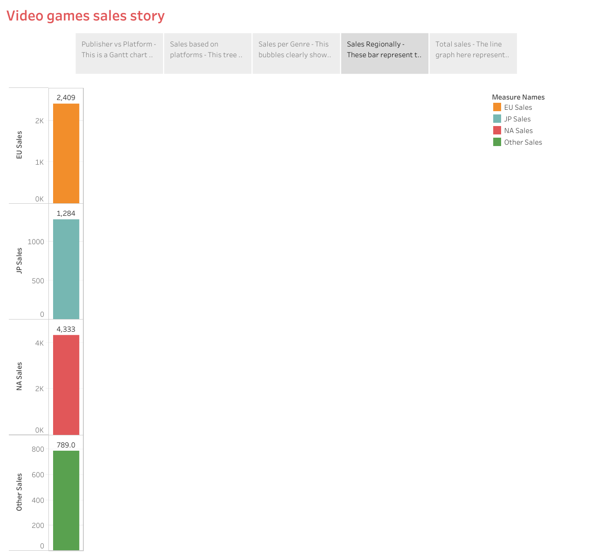

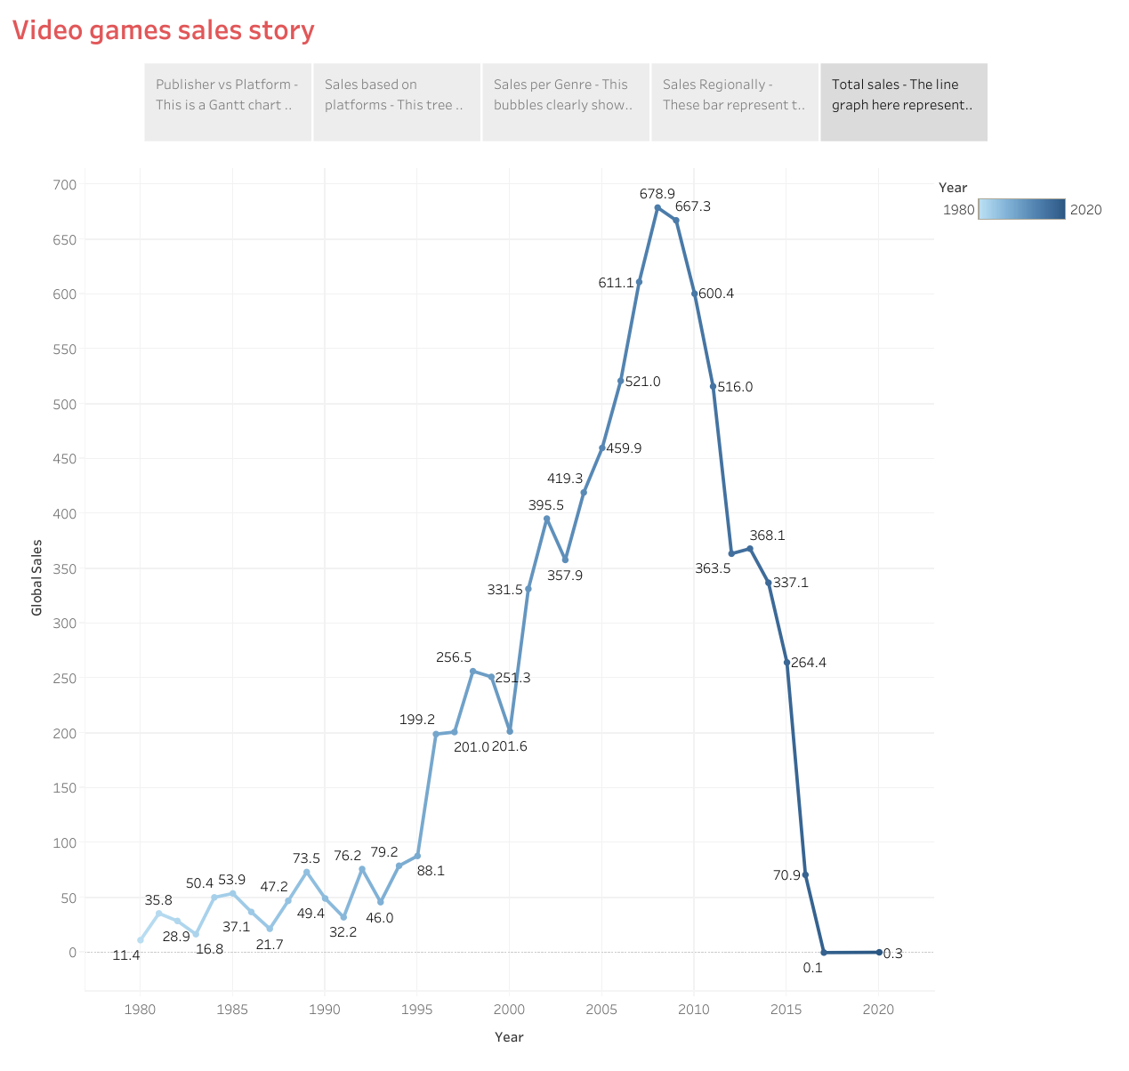

WEB APPLICATIONS

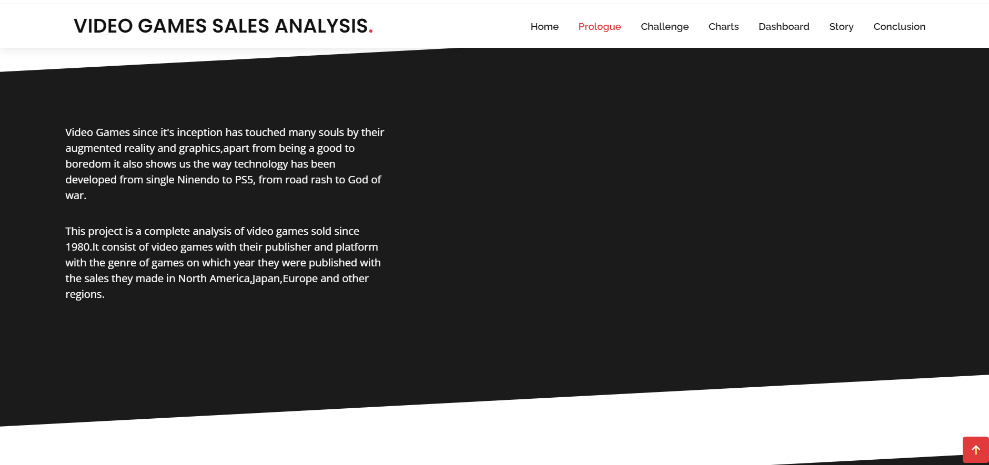

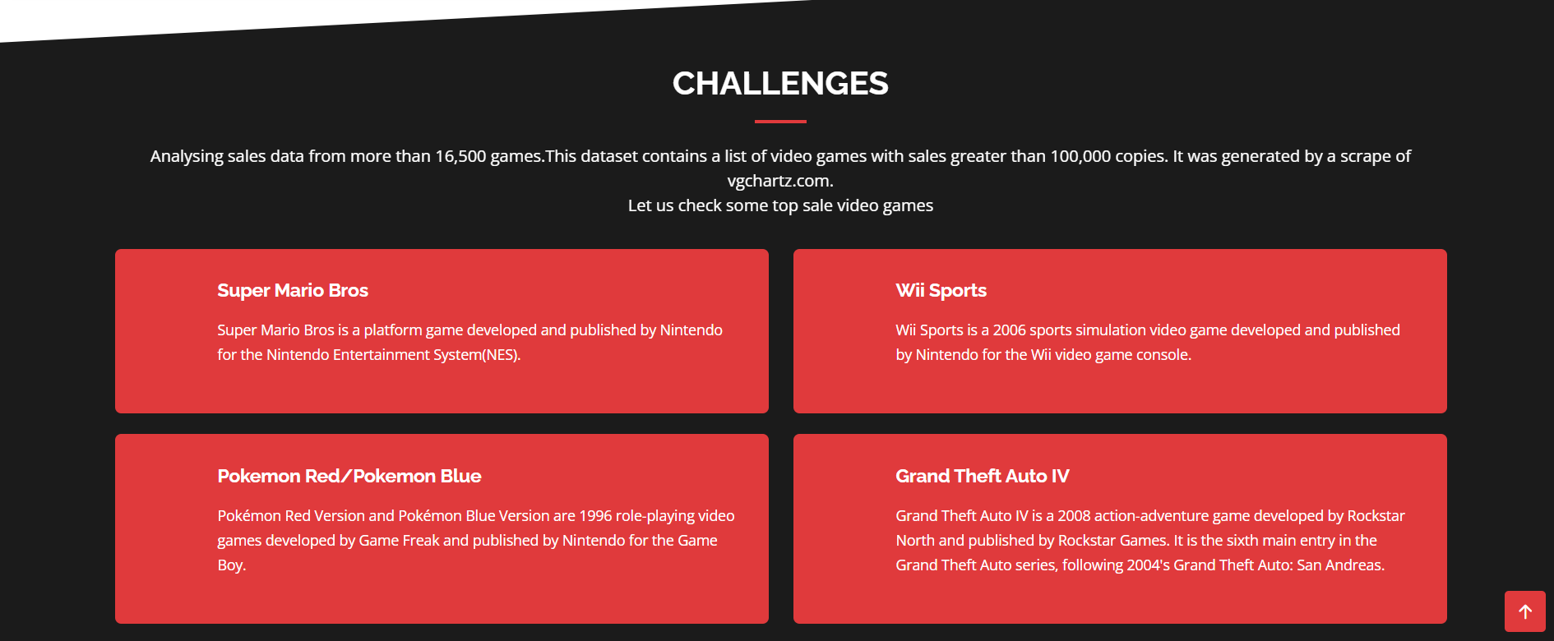

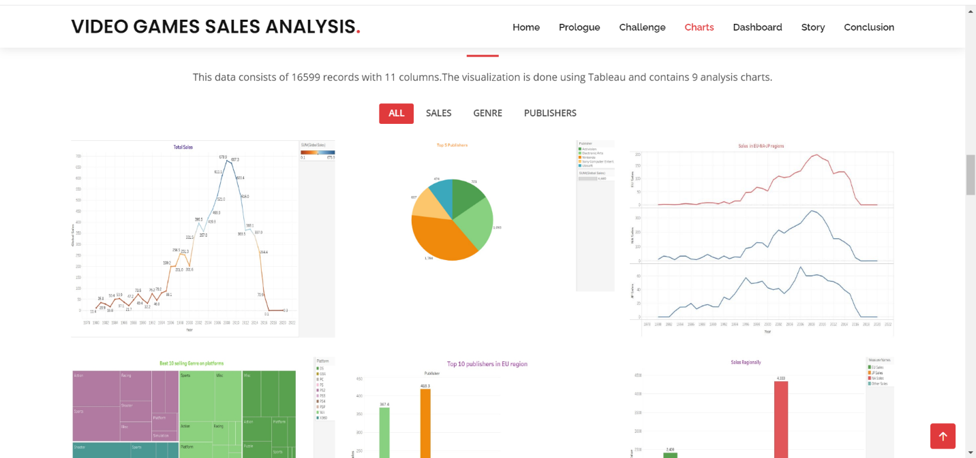

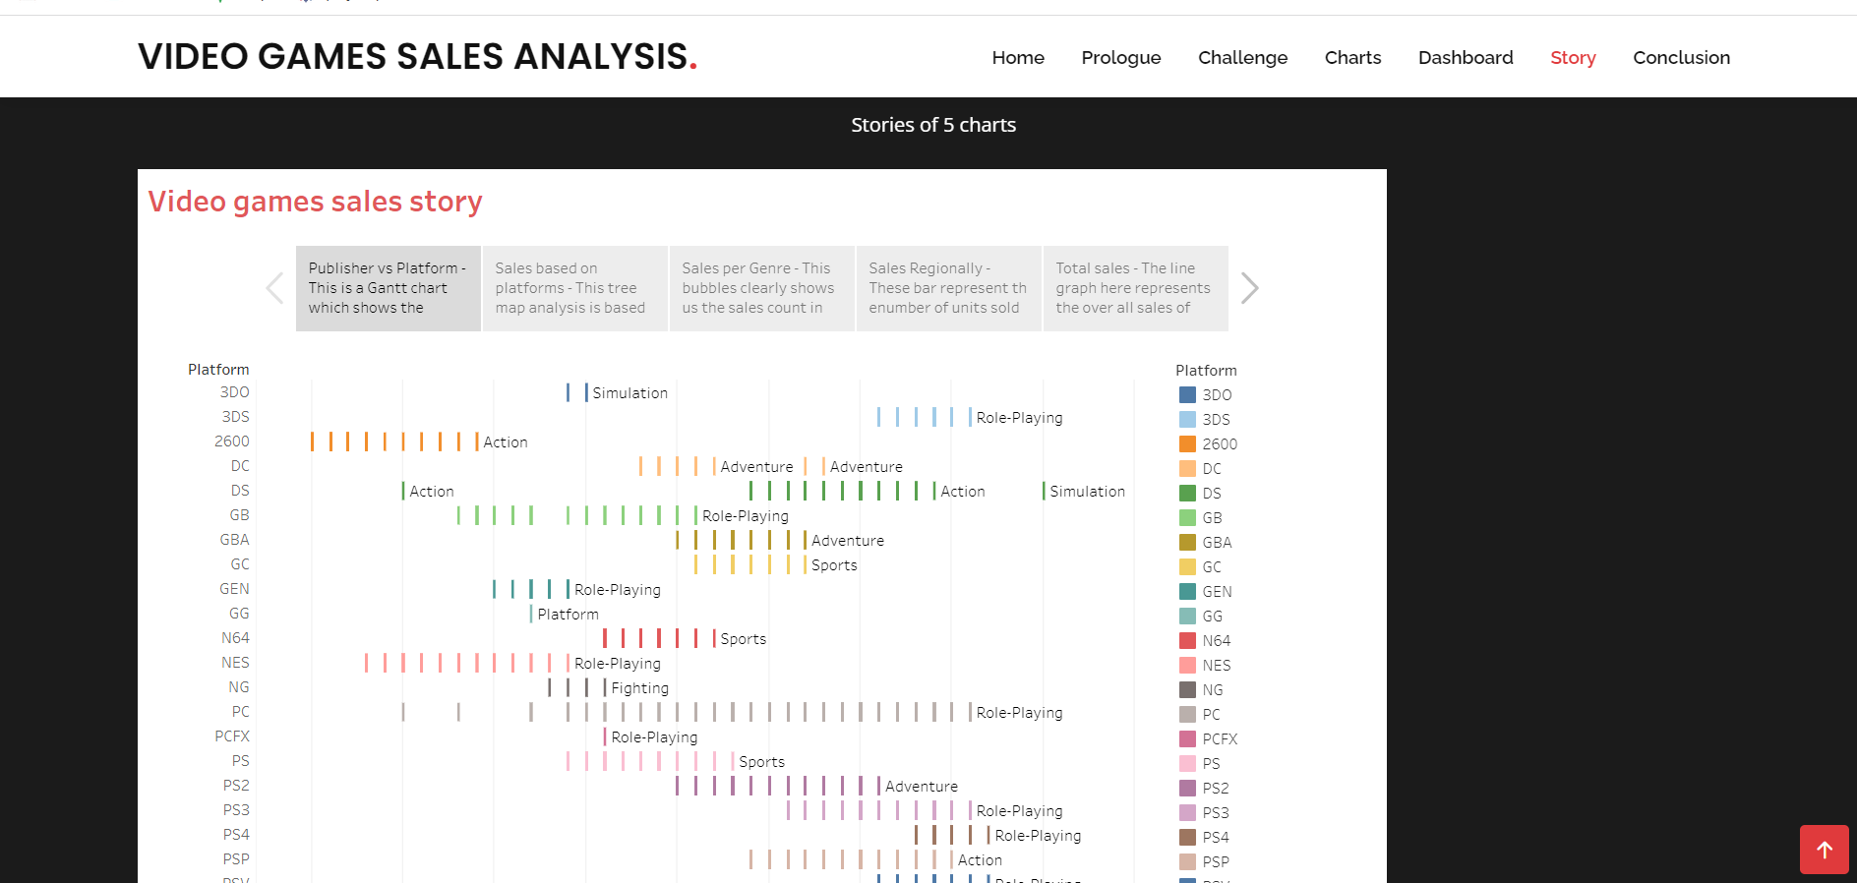

3.ADVANTAGES

\* Video games can improve manual dexterity.

\*Video games can increase your brain’s gray matter.

\*Gamers may have better social skills.

\*Games can teach you to be a better problem solver.

\*You can become more physically active as

a gamer.

4.DISADVANTAGES

\*Behavioral and mental changes.

\*Lack of other hobbies and poor academic performance.

\*Lethargic nature, which will also lead to weight gain.

\*Gaming addiction can slow down the brain growth.

5.APPLICATIONS

\*Video games can be used in the field of education.

\*Video games could help people overcome dyslexia.

\* Video games could help make you a better leader.

6. CONCLUSION

Gaming is now a bigger industry than movies and sports combined. Revenue for gaming reached $184 billion in 2022, and the number of gamers is expected to grow to 3.6 billion by 2025.

7.FUTURE SCOPE

There is a very wide and bright future in gaming design in India. Students can earn upto 3lakh to 5 lakh PA. The Indian gaming market is expected to grow from $2.8 billion in 2022 to $5 billion in 2025.

THANK YOU